Christine Harker
Professor Mangini
Eng 100: Research Paper, Draft #3
30 April 2018
Our Nation’s Healthcare Hypocrisy
Hundreds of thousands of people have died in this country, for no other reason than that they did not have health insurance (Cecere). The United States uses a health care system called multi-payer health care. In the multi-payer healthcare structure, individuals choose between competing insurance companies. This system is looked down upon by many other governments in the industrialized world. The United States and Mexico are the only two countries of the Organization for Economic Co-operation and Development (OECD) that do not have universal healthcare (OECD). Many other countries have adopted a universalized single payer system. A single payer system is where there is only one public agency that finances healthcare through alternative means, such as taxes, while not aiming to make a profit. This allows for cheaper and more accessible medical treatment for a country’s population. Sixty-two percent of bankruptcies declared every year in the United States, are caused by medical bills (Himmelstein). In addition, almost seventy-eight percent of these are from people who are insured (Himmelstein). The United States of America should adopt a universal healthcare policy to be both morally sound and fiscally responsible.
Universal healthcare is a system with boundless moral potential for improving the everyday American’s life and health. In 2009, the Harvard Gazette cited a study by The Centers for Disease Control and Prevention (CDC), that assessed death rates after taking into account education, income, and many other factors, including smoking, drinking, and obesity. The CDC study estimated that lack of health insurance causes 44,789 excess deaths annually (Cecere). This number is a travesty. This figure is up 27,000 from 2002 (Cecere). According to a Commonwealth Fund supported study, the United States ranked last on a list of 16 wealthy countries in preventable mortality (Commonwealth Fund). Preventable mortality is the number of deaths for which the underlying cause is avoidable. As an individual who has suffered from a serious disease, the cost of healthcare is a dominate part of my life. Over twenty-five percent of my yearly income is taken by insurance premiums and co-pays. I have been in support groups where my friends have had to make the decision on whether to buy food or the medicine that will let them digest it. In a study by the Kaiser Family Foundation, twenty-six percent of Americans report that they or a family member have had trouble paying for medical bills in 2012 and fifty-eight percent reported they did not immediately seek medical attention due to the high cost of said care (Kaiser Family Foundation). According to a document signed by the United States in 1948 while writing the basis of what would become the Geneva Conventions, healthcare is considered a universal and human right (United Nations). The United Nations recognizes withholding of basic medical needs an act not in accordance with their beliefs. America was one of the founding members of the United Nations in 1945. America will not allow a foreign power to let their prisoners of war go without treatment but has no issues letting their own citizens die for such insignificant reasons. This is both incredibly senseless and hypocritical. As a nation that states that we are the greatest in the world we should treat our citizens with the same consideration that we hold other countries to.
The United States of America should use a universal healthcare system for moral reasons, and for financial reasons as well. After the adoption of the new system, the country could lower its average spending on healthcare by $592 billion dollars and over $1.8 trillion in the following decade due to lowered administrative and drug costs (Friedman). In addition, the following graph from the LA Times shows that the United States pays almost three times on healthcare as the average of other countries with comparable incomes.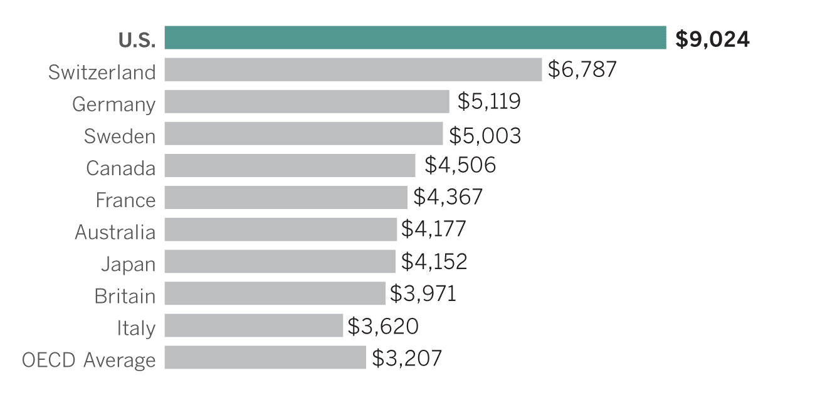
Source: Organization for Economic Co-operation and Development. (L.A. Times Graphics)
Not only is there the direct cost of healthcare there are additional costs as well. In a report by the Institute of Medicine report, the uninsured costs the U.S. economy 65-130 billion a year because of poor health and premature deaths (Future Survey). Our government spends roughly $262 billion annually denying medical claims (Sandborn). The US Government spends money actively denying healthcare claims. There are around three trillion dollars in claim-associated-costs filed every year and about nine percent of those are initially denied (Sandborn). Of that nine percent denied, every claim has to be looked over by people who are paid to do nothing else. Of the claims that are reassessed, there is only a sixty-four percent success rate and only twenty-nine percent of those result in reimbursement (Sandborn). Overall universal healthcare will save the country billions in the long run. If we used the billions spent in administrative costs for denying claims it would help to offset the costs of providing universal health care. There would be a substantial increase in our economy as well due to a living healthier workforce.
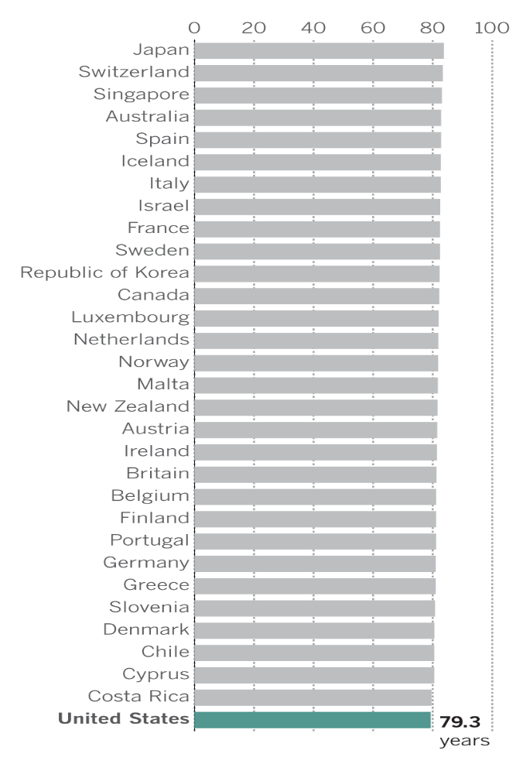
Despite the overwhelming amount of both factual data and moral arguments for universal healthcare, there are some who do not understand why we need it as a nation or those that outright oppose it. There are many members of the government who even protest the adoption of a universal health care system. Most people against universal healthcare end up citing these three basic grounds of denial. The first argument is the system is far too expensive. While a tax increase is necessary for universal healthcare to function as the system stands today; that does not mean that healthcare will cost more for the average American. In fact, monthly spending will drastically fall because of the expense that those are paying for their healthcare a month greatly outweighs the tax increase on their wages. We spend so much on co-pays, premiums, and prescriptions that we could be saving hundreds a month (Moore).

The second argument is that the quality of healthcare will diminish. Our healthcare is not the top care amongst industrialized nations. We rank below thirty other countries worldwide because we do not have universal healthcare. Countries with universal healthcare have a longer life expectancy for its populace than we do. Our average life expectancy is only 79 years compared to the 80 or more years that countries such as Japan, Canada, and Chile have as shown to the left in the graph Countries with longest life expectancy, 2015 (La Times).

The third argument is that because of increased access to healthcare more people will seek medical attention that do not require it. This argument uses the example that after the poor populace in Portland, Oregon started to receive Medicaid that emergency visits went up forty percent (Taubman). This is not due to the populace seeking unnecessary medical attention; this is however a byproduct of the populace no longer having to fear thousands of dollars of debt due to a non-lethal injury. Many people do not seek medical attention they need as stated by the thousands that die of preventable and treatable illness every year in this nation. Most citizens have been in the tough situation of worrying if they or their loved one can afford treatment. People are more willing to seek the medical attention that they require when there is not a threat of debt behind it.
In conclusion, to quote the document we hold all other countries accountable of: “Good health is essential to human welfare and to sustained economic and social development” (World Health Organization). While some politicians may be skeptical the Universal Healthcare System is something this nation not only wants but desperately needs. The United States of America should adopt a universal health care policy to be both morally sound and fiscally responsible. The adoption of this system would not only save thousands of lives and make the everyday American’s life easier, but it will also save the average American immense amounts of money annually. Universal healthcare is not only the fiscal choice, but it is the moral one as well. There would be less US citizens who would be afraid to visit their doctor or afraid that their illnesses would bankrupt them. No more individuals who must give up more than half of their paychecks to be able to afford the medication they need to survive. We even as a nation have set this standard for others. In 1948 the United States signed the United Nations Universal Declarations of Human Rights. It stated that “everyone has the right to a standard of living adequate for the health and wellbeing of one’s self and one’s family including… medical care” (United Nations). While we have this unfair system, we set the standards for other countries to have healthcare as a right and not a privilege. Life, liberty, and the pursuit of happiness are supposed to be our American rights. When did our lives become a privilege and not a right. Healthcare should not be about profit for big corporation. It deserves the same place in our society that we give our military, police force, and fire department as basic rights that all people can rely upon. Healthcare is not a luxury like an iPhone or a new sports car. It is a necessity for all people. Every person relies on healthcare in their lives. I hope that soon we, as one nation, make the right choice to help our neighbors and stand up for all Americans in this fight for our right to live. As it is, the United Nations states that by 2030 all of it’s members must have a Universal Healthcare system. It is time our nation stops worrying about the initial cost of a universal healthcare system and starts to worry about the 45,000 people each year that pay with their lives.

Works Cited

“Change Healthcare Analysis Shows $262 Million in Medical Claims Initially Denied, Meaning Billions in Administrative Costs.” Healthcare Finance News, www.healthcarefinancenews.com/news/change-healthcare-analysis-shows-262-million- medical-claims-initially-denied-meaning-billions.

Cecere, David. “New Study Finds 45,000 Deaths Annually Linked to Lack of Health Coverage.” Harvard Gazette, 6 May 2017, news.harvard.edu/gazette/story/2009/09/new- study-finds-45000-deaths-annually-linked-to-lack-of-health-coverage/.

Etehad, Melissa, and Kyle Kim. “The U.S. Spends More on Healthcare than Any Other Country - but Not with Better Health Outcomes.” Los Angeles Times, Los Angeles Times, 18 July 2017, www.latimes.com/nation/la-na-healthcare-comparison-20170715-htmlstory.html.

Haeder, Simon F. and David L. Weimer. "Inching toward Universal Coverage: State-Federal Health-Care Programs in Historical Perspective." Journal of Policy History, vol. 27, no. 4, Oct. 2015, pp. 746-770. EBSCOhost, doi:10.1017/S0898030615000330.

The Henry J. Kaiser Family Foundation, “Health Security Watch”, www.kff.org, June 2012.
Friedman Analysis of HR 676: Medicare for All Would Save Billions - PNHP's Official Blog, pnhp.org/blog/2013/07/31/friedman-analysis-of-hr-676-medicare-for-all-would- save-billions/.

"Hidden Costs, Values Lost: Uninsurance in America." Future Survey, vol. 25, no. 12, Dec. 2003, p. 13. EBSCOhost, search.ebscohost.com.libdb.dccc.edu/login.aspx?direct=true&db=aph&AN=12051871&s ite=ehost-live

​
Himmelstein, David U., et al. "Medical Bankruptcy in the United States, 2007: Results of a National Study." American Journal of Medicine, vol. 122, no. 8, Aug. 2009, pp. 741- 746. EBSCOhost, doi:10.1016/j.amjmed.2009.04.012

Morgan, Kimberly J. “America's Misguided Approach to Social Welfare.” Foreign Affairs, 15 Sept. 2015, www.foreignaffairs.com/articles/united-states/2012-12-03/americas- b misguided-approach-social-welfare.

Moore, Michael. “A Film by Michael Moore » WHERE TO INVADE NEXT.” WHERE TO INVADE NEXT, wheretoinvadenext.com/.

“New Study: U.S. Ranks Last Among High-Income Nations on Preventable Deaths, Lagging Behind as Others Improve More Rapidly.” The Commonwealth Fund, www.commonwealthfund.org/publications/press-releases/2011/sep/us-ranks-last-on- preventable-deaths.

OECD. Health Status, stats.oecd.org/index.aspx?DataSetCode=HEALTH_STAT.

“Sustainable Health Financing, Universal Coverage and Social Health Insurance.” World Health Organization, World Health Organization, 21 Dec. 2015, www.who.int/health_financing/documents/cov-wharesolution5833/en/.
Taubman, Sarah L., et al. "Medicaid Increases Emergency- Department Use: Evidence from Oregon's Health Insurance Experiment." Science, vol. 343, no. 6168, 17 Jan. 2014, pp. 263-268. EBSCOhost, doi:10.1126/science.1246183.

“Universal Declaration of Human Rights.” United Nations, United Nations, www.un.org/en/universal-declaration-human-rights/

US Census Bureau. Census.gov, www.census.gov/en.html.

